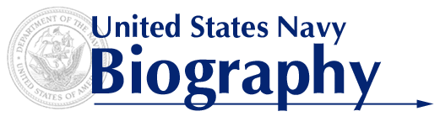
COMMANDER MICHAEL S. CLOUD
EXECUTIVE OFFICER
nROTC, SOUTHERN a&m UNIVERSITY

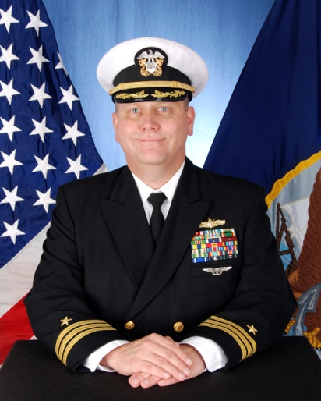
Commander Michael Cloud, a native of Tallahassee, FL, entered the Navy in 1989 and was commissioned through the Enlisted Commissioning Program in May 1999. He graduated from the University of New Mexico with a Bachelor of Arts and was designated a Surface Warfare Officer in 2001.

His previous sea assignments include service on USS Enterprise (CVN 65), USS Yorktown (CG 48), USS Cole (DDG 67), USS Mustin (DDG 89), Destroyer Squadron Fifteen, Carrier Strike Group TWO, Carrier Strike Group FOUR, USS Nitze (DDG 94), and Carrier Strike Group ONE. During his command of Nitze, Nitze was awarded the Battle Efficiency Award in 2018. He has completed multiple deployments with the Kitty Hawk, George Washington, George H.W. Bush, Dwight D. Eisenhower, and CARL VINSON Carrier Strike Groups. His most recent assignment was Surface Operations Officer, Carrier Strike Group ONE before assuming his current position as Executive Officer, NROTC Southern A&M University.

Ashore, Commander Cloud completed duty assignments as the Joint Air Defense Officer on the staff of Joint Combat Identification and Evaluation Team, Flag Aide to President, U.S. Naval War College, and Chief of Staff, Task Force 78.

Commander Cloud holds a Master of Science in Management from Troy University and a Masters of Arts in National Security and Strategic Studies from the U.S. Naval War College. He earned JPME Phase II from the National Defense University, Joint Forces Staff College in 2013.

Commander Cloud’s personal awards include the Meritorious Service Medal (Fourth award), Joint Service Commendation Medal, Navy and Marine Corps Commendation Medal (Fourth award), Navy and Marine Corps Achievement Medal (Fourth award) in addition to various other unit and campaign awards.

